MINISTRY OF SCIENCE AND EDUCATION NATIONAL TECHNICAL UNIVERSITY “KHARKIV POLYTECHNIC INSTITUTE”

DEPARTMENT OF SOFTWARE ENGINEERING AND MANAGEMENT INFORMATION TECHNOLOGIES

Report from lab#4

Discipline “Fundamentals of DataBase”

Executed by: Student of group 1.КН.201.8г

CHUKWU IRELE AMORIN

Checked by:

**Assistant Polovinka O.L.**

Kharkiv

2019

**Topic :** LEARN BASIC SQL DATA MANIPULATION COMMANDS

**Goal:** State the laboratory practice problem. Study how to use the commands SQL using SELECT queries.

1. **Print a list of products delivered by the supplier 1 (Ivanov I.I. PE) for the contract 1.**

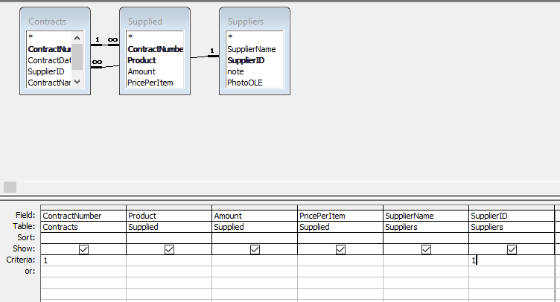

1. **Print a list of products delivered by supplier 1 (Ivanov I.I. PE) between 9/1/1999 and 9/12/1999 (using “mm/dd/yyyy” date format)**

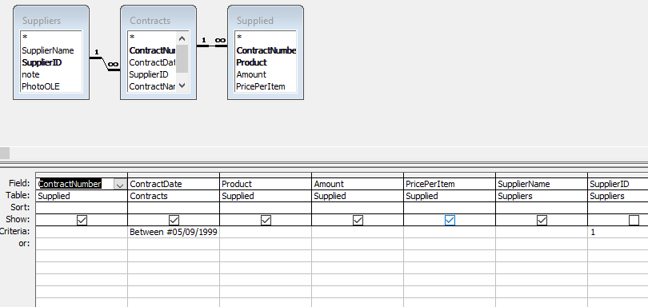

**3. Print a list of products supplied in September of 1999 with supplier name and supply date.**

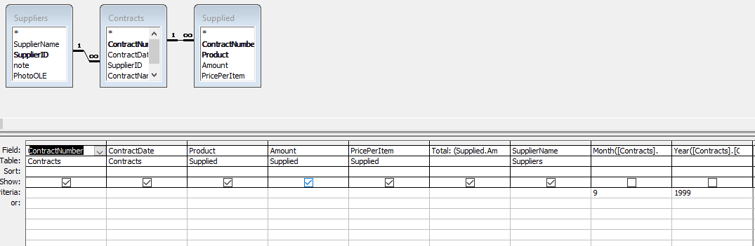

**4. Print a list of contracts (number, date), total amount of the supplied products and total price for each contract (multiply and sum amount and price for each contract). The list should be sorted by contract numbers (ascending)**

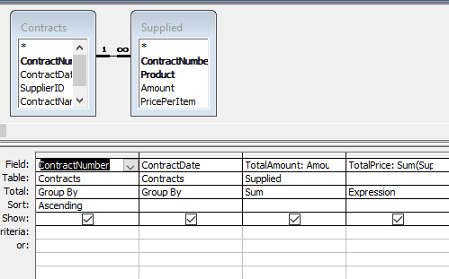

**5. Print a list of contracts (number, date) with total price for each contract. The list should be sorted by total price for each contract. Records**

**for which contract number is greater than 3 should be excluded from query results**

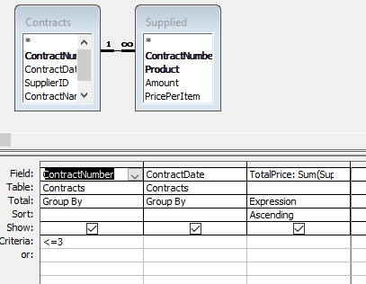

6. Print information about the largest product batch among all contracts. Include information about supplier, contract number, and date.

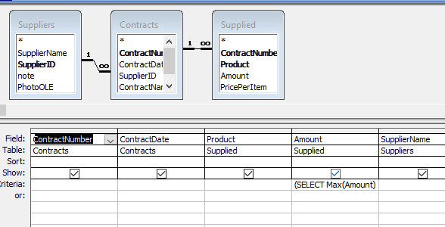

7. Print a list of suppliers (name and ID) that have not concluded any contracts.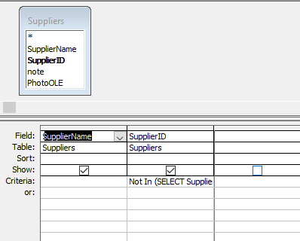

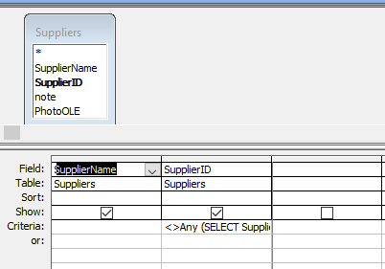

8. Print a list of supplied product names with the average price per item (regardless of supplier)

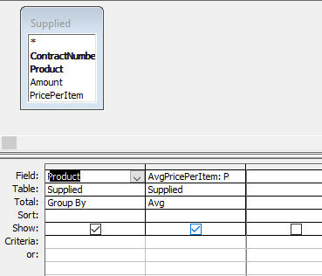

9. Print a list of products (name, amount and price, supplier) for which price per item is greater than average

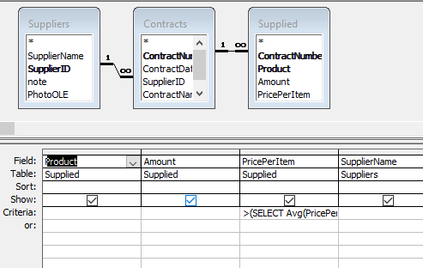

10. Print information about top five expensive products (name, price per item, supplier).

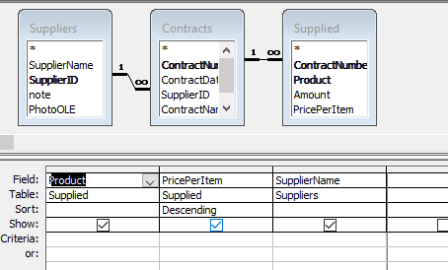

11. For each day of September 1999 define price of products delivered by each supplier (include only delivery days).

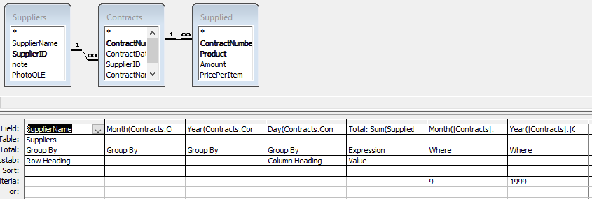

12. Create a list of contracts (only numbers), total amount of the supplied products, and total price for each contract. Print full names (last name, first name, and second name) of suppliers that are private entrepreneurs, as well as tax numbers of legal entities

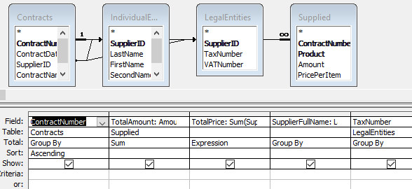

13. Define amounts of each delivered product by each supplier

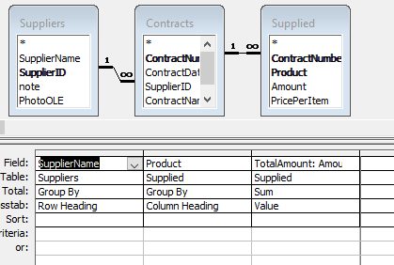

14. Print a list of contracts (number, date) and total price for each contract. The list should be sorted by total price for each contract. Exclude records for which the contract number is greater than a given value from the query result.

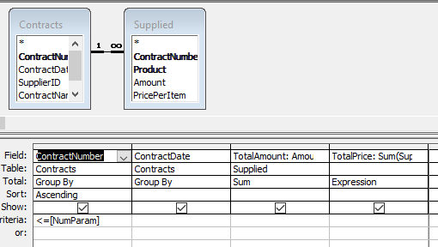

15. Create a list of products delivered by the suppliers 1 and 2 (“Interfruit” LLC).



16. Create a list of products supplied more than once

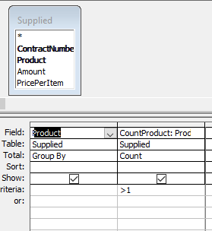

II. Data manipulation using SQL commands UPDATE and DELETE.

17. Increase amount of each product delivered by the supplier 1 by 10.

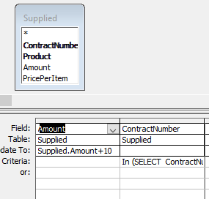

18. Delete all “empty” contracts (with no records about supplied products).

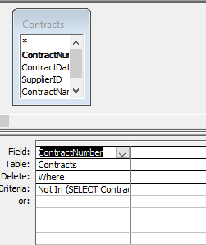

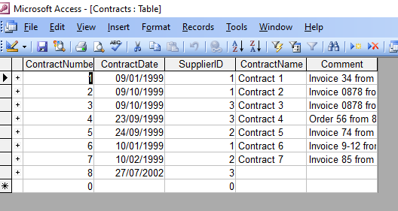

**Conclusion :**

At that lab were received knowledges about BASIC SQL DATA MANIPULATION COMMANDS, it`s usage and gotten practical skills that allows To implement SELECT SQL queries and create tab in the Access window using DBMS Access in this environment.